**Project Planning Phase**

**Project Planning Template (Product Backlog, Sprint Planning, Stories, Story points)**

|  |  |
| --- | --- |
| Date | 15 February 2025 |
| Team ID | LTVIP2025TMID37239 |
| Project Name | Health AI -intelligent healthcare assistant using IBM granite |
| Maximum Marks | 5 Marks |

**Product Backlog, Sprint Schedule, and Estimation (4 Marks)**

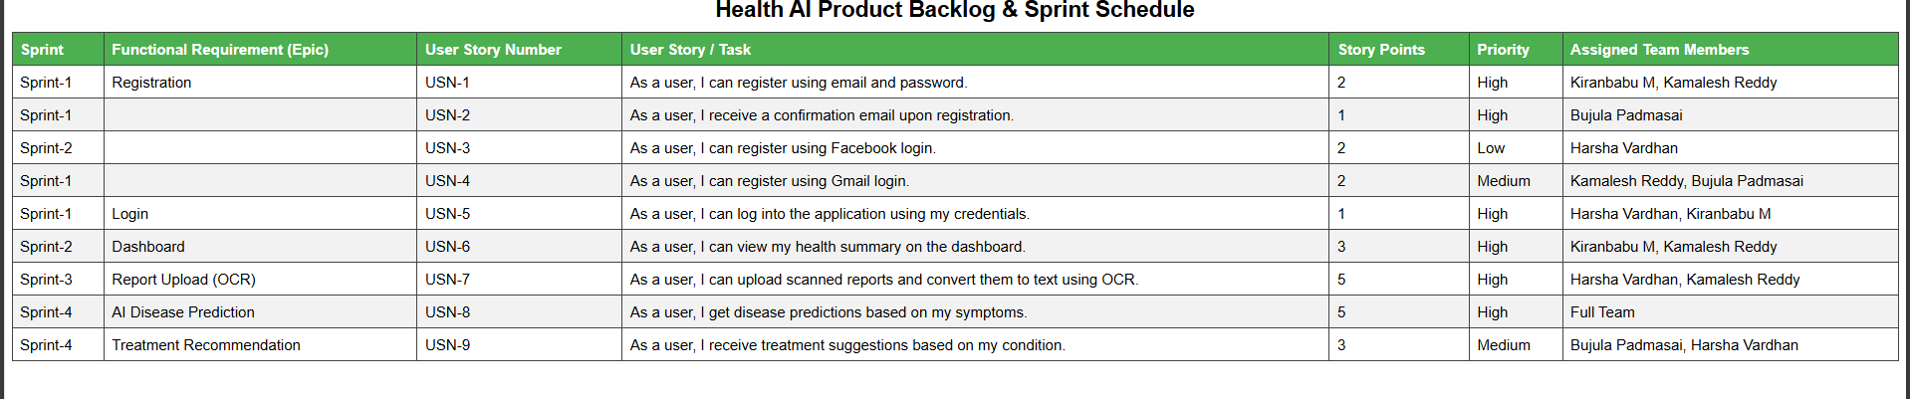

**Project Tracker, Velocity & Burndown Chart: (4 Marks)**

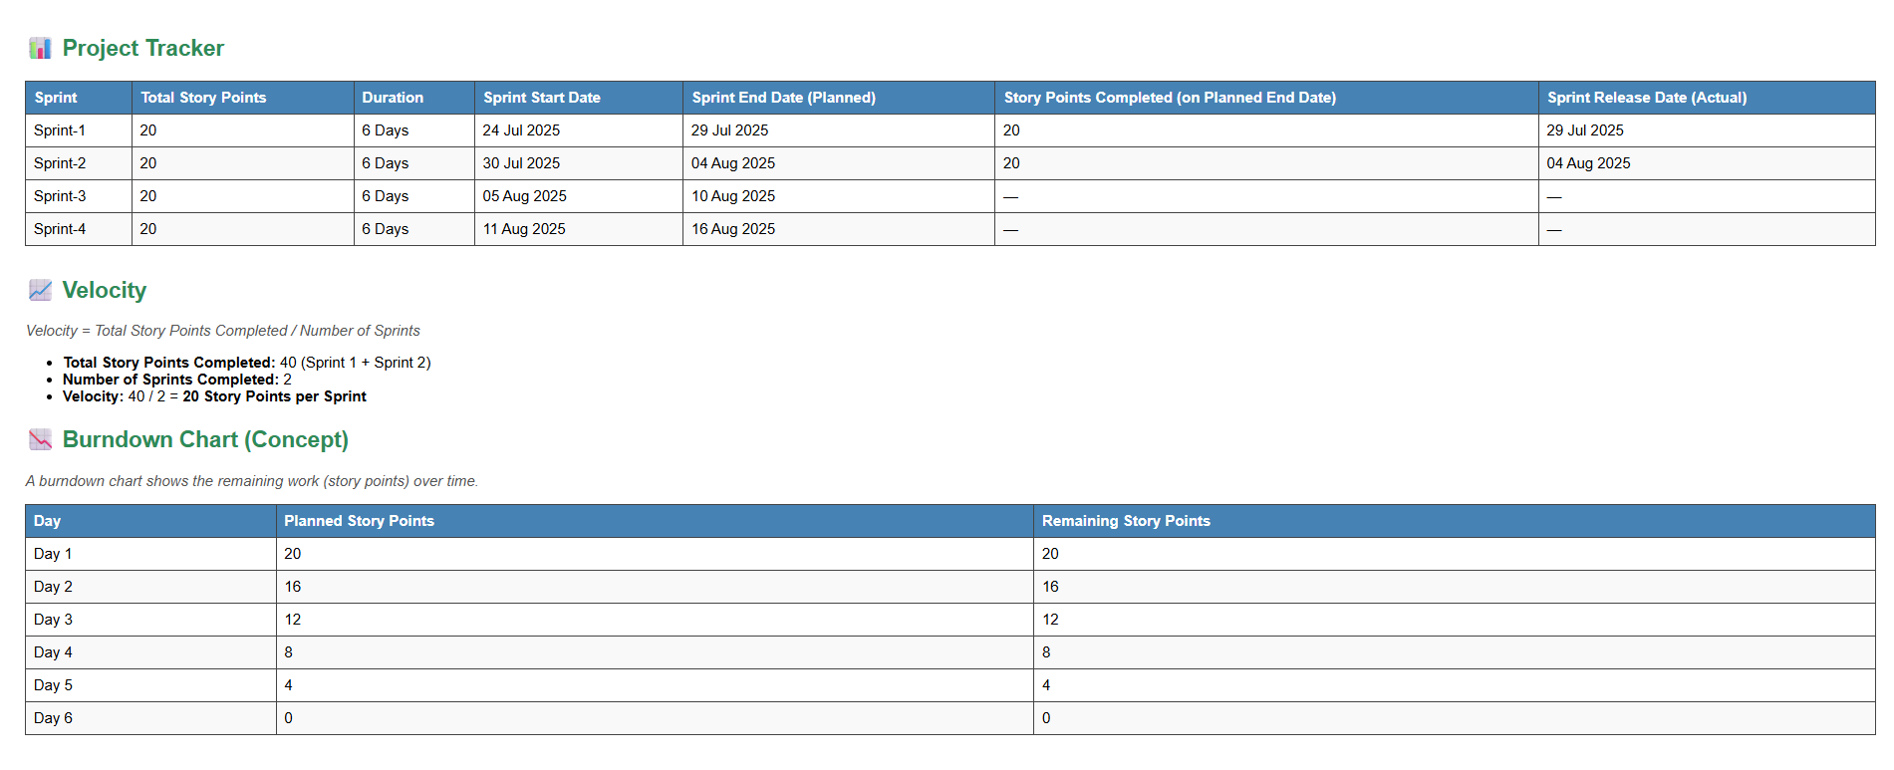

**Reference:**

[**https://www.atlassian.com/agile/project-management**](https://www.atlassian.com/agile/project-management)

[**https://www.atlassian.com/agile/tutorials/how-to-do-scrum-with-jira-software**](https://www.atlassian.com/agile/tutorials/how-to-do-scrum-with-jira-software)

[**https://www.atlassian.com/agile/tutorials/epics**](https://www.atlassian.com/agile/tutorials/epics)

[**https://www.atlassian.com/agile/tutorials/sprints**](https://www.atlassian.com/agile/tutorials/sprints)

[**https://www.atlassian.com/agile/project-management/estimation**](https://www.atlassian.com/agile/project-management/estimation)

[**https://www.atlassian.com/agile/tutorials/burndown-charts**](https://www.atlassian.com/agile/tutorials/burndown-charts)